PREPARE PYTHON ENVIRONMET

Task 1 : Download and install python environment configuration.

Step 1: Download python setup from official website (https://www.python.org/downloads/)
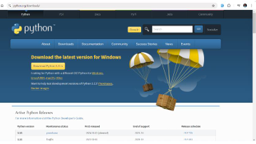

When the download complete:
Step 2: Run the installer
Step 3: follow the on screen instructions until the setup install complete.

Picture 1:
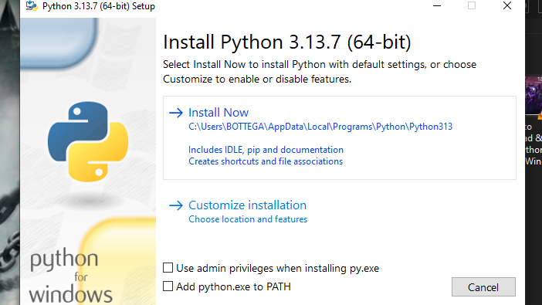

Picture 2:

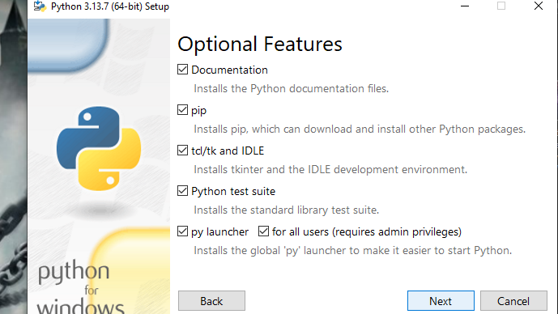

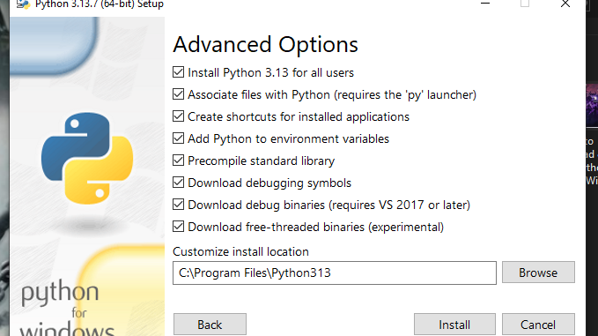
Picture 3:

Complete the set up installation of python

Picture 4:
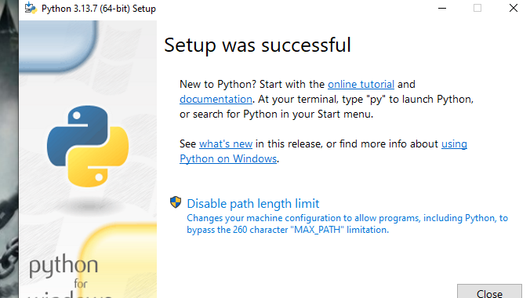

Step 5: Once the installation is complete verify the installation by cmd.
Step 6: type python --version and press enter
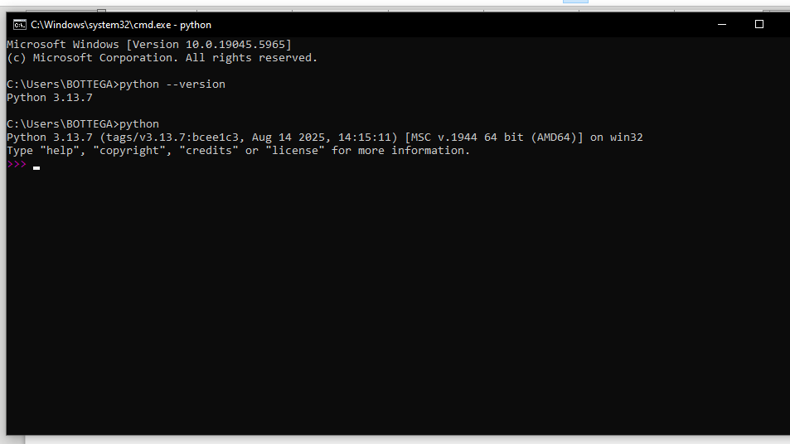

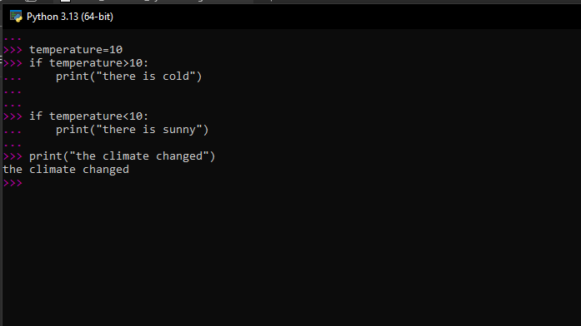
Here there is an example of python program that will notify if the climate is changed

END.

MEMBERS

- UWIRINGIYIMANA Clementine

- INGABIRE Olive

- UWIMANZI Fabienne

